CO2: Formulate hypotheses, apply statistical tests and evaluate results to draw valid conclusions from data.

Problem Solving Assessment

1: A/B Testing in E-Commerce
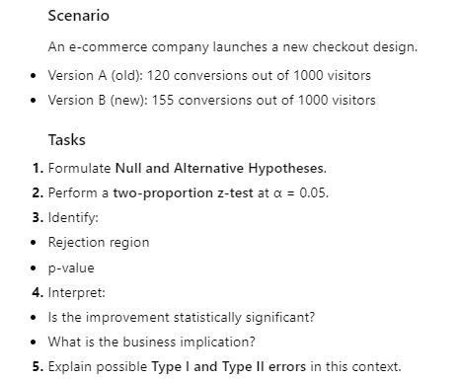
2: Hospital Treatment Effectiveness
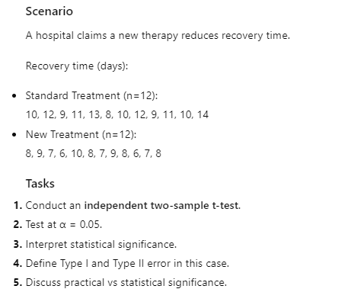

3: Teaching Methods
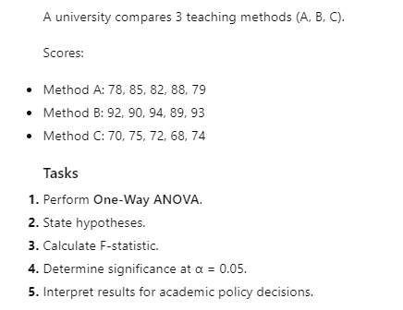
4: Customer Behavior Analysis
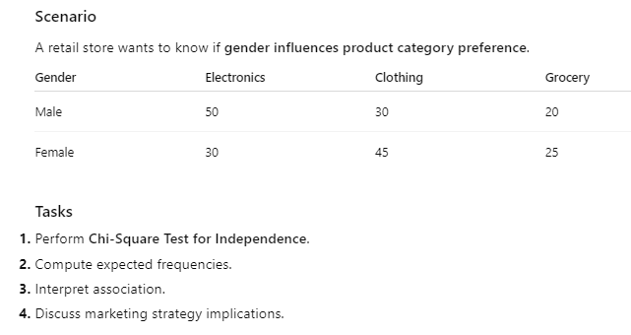

5: Advertising Budget vs Sales
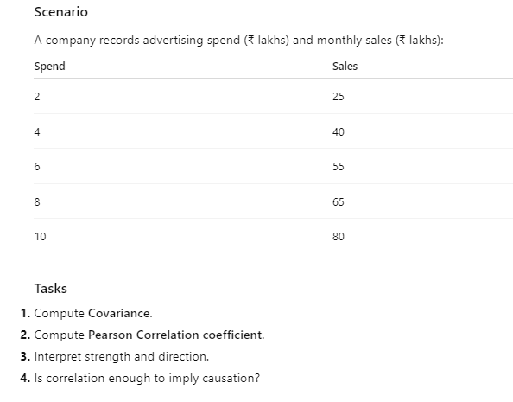
6: App Engagement Improvement
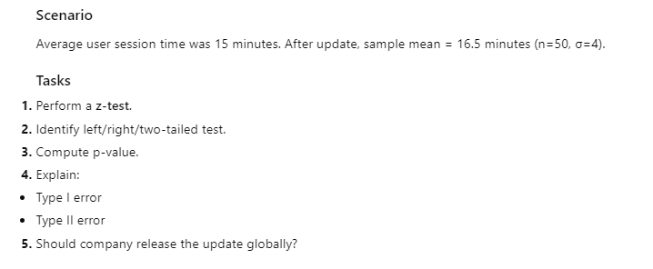

7: Feature Importance & Statistical Significance
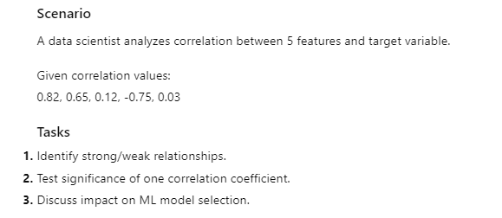
8. Manufacturing Quality Control
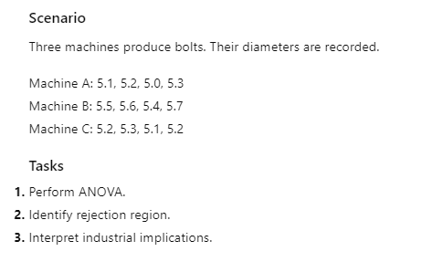
9. Warehouse Delivery Time Reduction
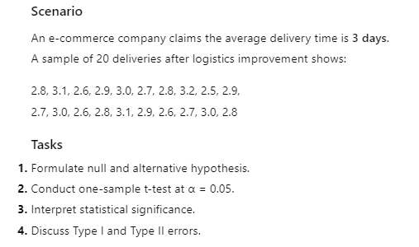
10. Fraud Detection Model Improvement
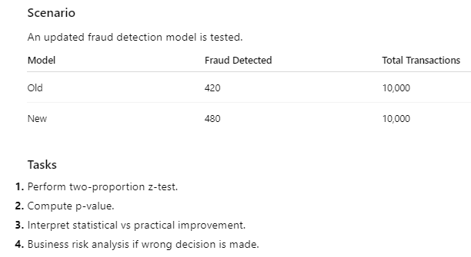
11. Production Yield Comparison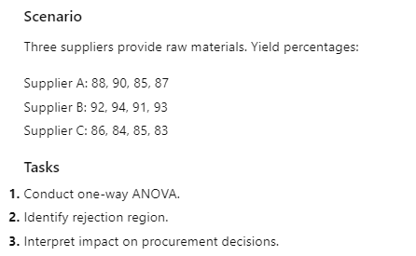

12. Social Media Sentiment & Sales
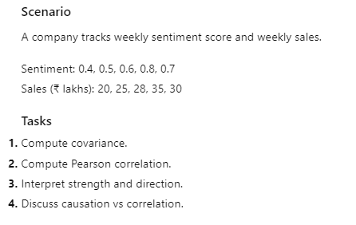
13. Medical Diagnosis Association

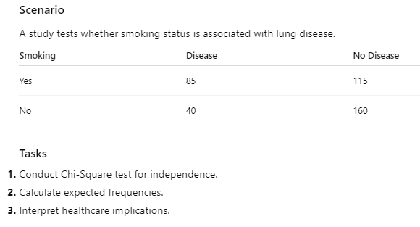

14. Student Performance Before & After Online Learning
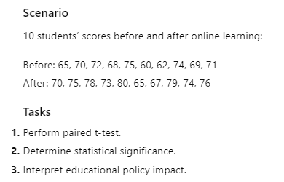
15. App Crash Rate across OS Versions
